CROMARTY COMMUNITY INDOOR TENNIS CENTRE (CCITC)
A Public Hub Facility Serving The Entire CBRM
Registered 2006 - Nova Scotia Societies Act / Registered 2008 - CRA Canadian Charitable Organization
ccitc@cromartytennis.ca - www.cromartytennis.ca/ccitc - Sydney, Nova Scotia, Canada
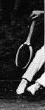

Nova Scotia Non-Profit Society Registry ID: 3166973
Business Number (A Canadian Registered Charity): 848036968RR0001
_______________
CLASS C CAPITAL ESTIMATE
Proposed Building and Tennis Court - At The Sydney Airport Authority
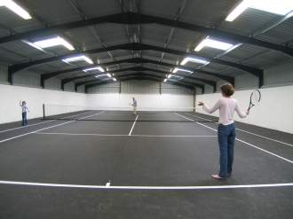
(Closely resembles the proposed facility)
"We Are Shovel Ready and Eager To Build"

The prime goal of the CCITC is to ensure the successful construction and the on-going operation of an indoor public tennis facility, while meeting all of the charitable and ancillary activities as described in the seven objects of the Society. For a $600,000 capital investment, the minimum amount necessary to achieve the prime goal, the facility would take a certain basic, cost-effective, form. Naturally, a greater investment would produce additional enhancements, such as a larger building, extra tennis courts, full running track, year-round air-conditioning, etc.
The proposed heel chair accessible building, located at the Sydney Airport Authority (with nearby sewer and water for our site readily available), will serve up the standard four walls, a white ceiling, indirect court "green" lighting, a superior insulated "green" envelope, an economical "green" heating system, basic washroom facilities (attached), and a first class alternate-style cushioned tennis court as follows:
(1) Consulting Fees - $00,00
(2) Site preparation and concrete reinforced slab on grade with frost wall for the main building, plus a slab for a small washroom as an appendage - $100,000
(3) A "pre-engineered rigid framed" steel building, 80' wide x 140' long, with c. 26' high side walls and c. 39' to a central ridge, with a 5:12 roof pitch - $240,000
(4) Building Assembly - $60,000
(5) Superior "green" insulation (Walls R20, ceiling R40) with either indirect ventilation through ceiling-mounted exhaust fans or natural infiltration - $70,000
(6) Propane gas-fired high-intensity infrared radiant ceramic ["light"] "green" heating system (Eight (8) Modine MT 90s) maintaining a 55 F degrees [12.7 degrees C] inside winter temperature - $10,000
(7) Electrical utilities and installation of sixteen (16) 12-lamp Indirect "green" T5 fluorescent blue light technology - For example, Courtlite ) - $17,000
(8) Basic washroom amenity (appendage) connected to nearby water and sewer - $15,000
(9) An automatic active fire suppression system - $13,000
(10) Security and fire monitoring system- - $10,000
(11) One (1), state of the art, cushioned, doubles court measuring overall 60' x 120' centred upon a cushioned area measuring 80' x 140' - $35,000
(12) Miscellaneous (Lawyer fees, insurance, permits, landscaping, tennis building furnishings/fittings/equipment) - $30,000
Note: A successful tender on a turnkey facility (but not including the tennis court) might produce a measurable savings in cost. Also, we expect some savings in some in-kind volunteer labour and materials from the local business community.
_________________________________
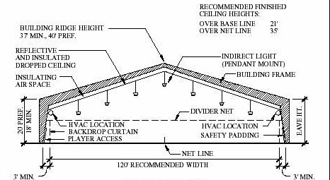
_________________________________
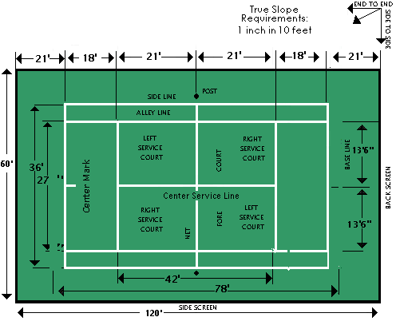
http://www.novasports.com/tencrt.htm

_________________________________
Several examples of possible state-of-the-art cushioned surfaces
(produced from environmentally friendly products)
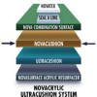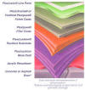
NOVA SPORTS: http://www.novasports.com/products_NOVACUSHION.htm /
and
PLEXIPAVE: http://www.plexipave.com/systems/tennis/plexicushion/plexicushion.html
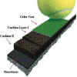
http://www.accuratetennis.com/services/construction/cushion.html
A shock absorbing feature that provides players with a firm playing surface, that reduces the risk of pulling muscles or twisting ankles, that is less traumatic on joints than traditional surfaces, and that is a superior health alternative for participants of all ages.

