NAVIGATE THE PAST
Sydney Record
April 15, 1901

Contributed By
Neil Libbey

The Cape Breton Yacht Club was organized in the Sydney Hotel on Friday October 13th, 1899, thirteen members being present at the time, and the room selected for the temporary home of the club was No. 13. A Thirteen Club could not have come into being under more auspicious circumstances, and it must be confessed that sundry qualms disturbed the breasts of the superstitiously minded. Nevertheless the Cape Breton Club (now the Cape Breton Yacht Club) has had an unprecedented run of luck. The president selected on this occasion was His Honor Judge Dodd. The other principle officers being F. C. Kimber, secretary, and H. H. McDougall, treasurer.

Early in January the new home of the club was completed, and at the first regular meeting the name of the organization was changed to the Cape Breton Yacht Club. At that session the following officers were unanimously elected: Commodore, His Honor Judge Dodd; Vice-Commodore, Arthur J, Moxham; Rear-Admiral, Shirley Davidson; Treasurer H. H. McDougall; and Secretary F. C. Kimber.

The new Cape Breton Yacht Club building was erected by Schurman, Lefurgey, Clark & Co., contractors under the supervision of R. B. Whitten, architect, the designer being R. C. Sturgis of Boston. The plumbing and heating were installed by Shaw & Beairsto and the electric lighting by De Witt & MacKinlay. The wharf was built by Job W. Dobson, of Westmount.

INTERIOR DECORATION

The decoration of the interior of the club, which is about completed, has been going on for nearly a month, and, is without doubt a triumph in the way of adornment. The work was executed under the direction of W. Henry Bell, designer and consulting decorator of the N. Y. Mantel and Decorating Co., Montreal, who has taken a strong personal interest in the club and its members. Mr. Bell was engaged by Mr. Moxham to decorate the latter’s new residence at the Rockaway and his engagement by the Cape Breton Yacht Club was largely due to his successful work at Mr. Moxham’s.

The walls of the entrance hall are hung with forest tapestry, with a rough lins par dado done in tan, a 5/8 inch manila rope separating the dado from the forest effect. The woodwork is painted in the forest green, and the coat room off the hall is enameled from floor to ceiling.

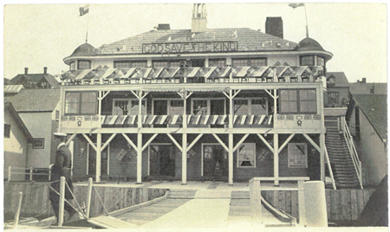

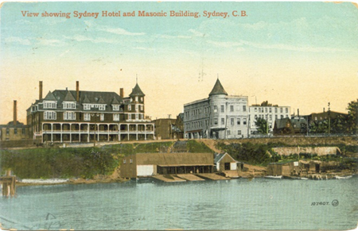

The Ladies’ Room is one of the prettiest apartments in the building. The walls are enameled in Marie Antionette silk paper, of a shell pink tint and ivory. The panel border is a poem in pink ribbon and roses, while the style of panel is white and grey moire silk. The ceiling is hand modeled in relief, with floral relief panels. To set off this charming corner, Mrs. Bell has presented the club with a set of rich chintz curtains in rose and yellow.

But it is in the club room that Mr. Bell has metaphorically spread himself. The nautical idea is here more plainly expressed. The frieze is hand modeled in majolica porcelain, and the subject is the Armada conventionalized. The main decoration consists of Pompeian red tapestry, and the woodwork is in forest green. The furniture in this room is made of Flemish Oak and upholstered in Spanish leather. An old colonial fireplace, in Old Dutch design, preaches comfort to the weary clubman, as his feet rests upon a rug richly colored in Pompeian red, with an intermixture of blues and greens.

The billiard room is surmounted with wainscoting and seats in cherry and the walls are painted in olive green. The tables are of English make. The fireplace is of modern colonial design. The staircase leading from the club room to the first floor and the hall above is decorated in Pompeian red stripe, and the ceiling and frieze are painted in deep cream, and the woodwork, forest green.

The reading room is hung with Empire green and gold tapestry, the ceiling ivory and the frieze in warm tan, with ebony molding separating the main decoration from the frieze. The furniture in this room is of Flemish Oak, upholstered in Spanish Leather. The decorations of the coffee room are in hand made China blues, of Morris design (modern school) with cream ceiling, the woodwork being in golden brown.

