Long Service Awards Presentation

Hear Ye! Hear Ye!
national historic sites on cape breton island lieux historiques nationaux du cap-breton
vol 9, no 6, June - Juin,2007

June 12th as part of Public Service Week, Long Service Awards were presented to a number of staff. Staff was invited to “drop in” to the Bigot Theatre at their convenience. Pictured below are some employees receiving their awards from Carol Whitfield.

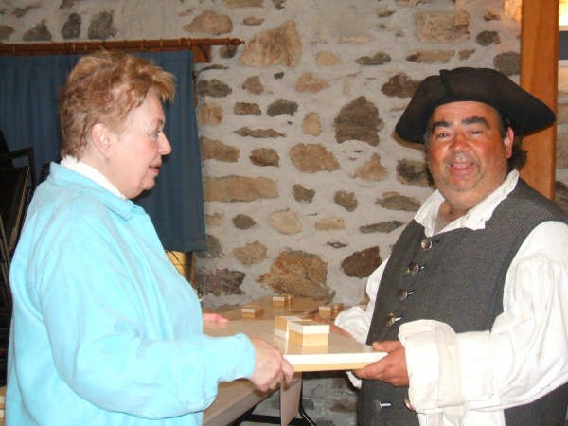

Adrian Samson – 25 Years

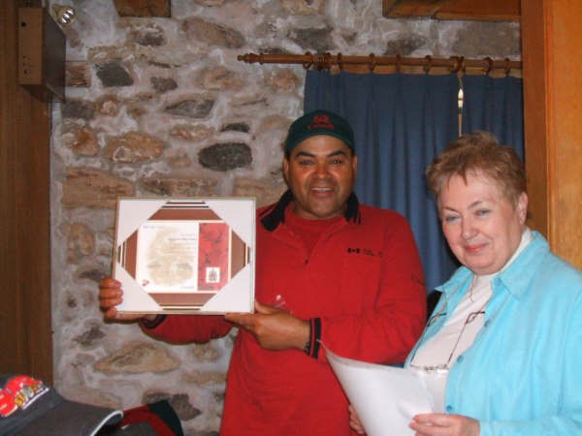
Ben Green – 15 Years

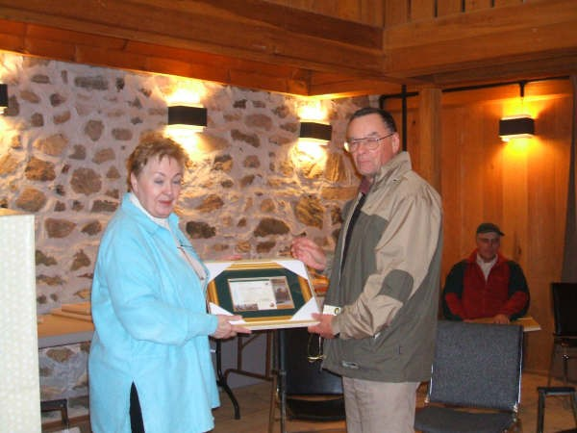

Charles Blanchard – 35 Years

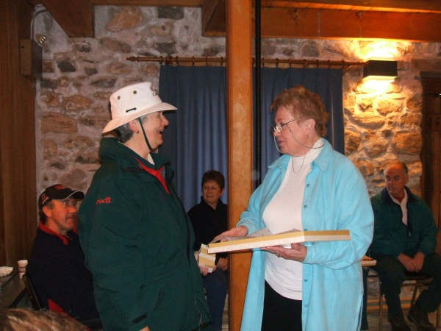
Louise Johnston - 25 Years

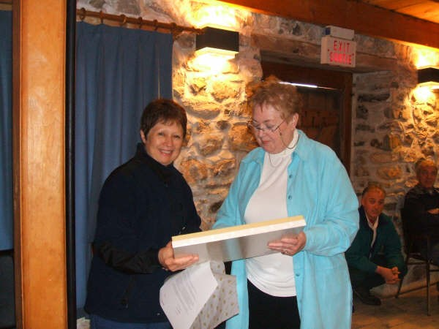
Wendy Bryan – 25 Years

Visit of Garden Scholar

Marie-José Fortier, who is writing a doctorate on the gardens of New France at the University of Montreal, was in Louisbourg from 20 to 23 June studying the gardens of Louisbourg. Ms. Fortier toured the Louisbourg gardens with Nicholas Whalen and Geraldine Joyce. She examined the archaeological garden artifacts with Heidi Moses. She also studied the historical documentation and toured the library with Ken Donovan. Marie-José Fortier, who will be the first person from Quebec to complete a doctorate on the history of gardens, sends a gracious thank you to the Louisbourg staff who made her visit so worthwhile.

Papers presented

Ken Donovan presented a paper on "The Era of Little Creatures: Puppets, Figurines and Theatre in Louisbourg, 1713-1758" at the French Colonial Historical Society Conference, in La Rochelle, France, 6 - 10 June 2007.

Anne Marie Jonah, John Johnston, Sandy Balcom and Ken Donovan presented papers on the various aspects of Louisbourg's history at the Atlantic Canada Studies Conference entitled "Knowledge in Action", Saint Mary's University, Halifax, 3-5 May 2007.

Ken Donovan will present a paper on slavery in Louisbourg at the conference "Commemoration 2007: The Bicentennial of the End of the Slave Trade 1807-2007, It's Impact Today and Our Community and You" at St. Mary's University, Halifax, 25-30 June 2007.

Publications

Anne Marie Lane Jonah, Historian, and Elizabeth Tait, Curator of Textiles, have combined to produce a publication entitled:

“Filles D’Acadie, Femmes De Louisbourg : Acadian Women and French Colonial Society in Eighteenth-Century Louisbourg”, French Colonial History, vol. 8, 2007.

News from AGB, NHSC

Interview with Alexander Graham Bell - Excerpt from a magazine article titled “How to Keep Young Mentally” December 1921:

“I believe that self-education is a lifelong affair. It comes, naturally and inevitably, through using the mind in the three (Observe! Remember! Compare!) ways I have pointed out. And I may add that following this ‘Rule of Three’ seems to be the greatest factor in keeping the mind young and active. There cannot be mental atrophy in any person who continues to observe, to remember what he observes, and to seek answers for his unceasing hows and whys about things.”

Explorer Quotient

The Explorer Quotient Demonstration Project is moving forward. The written material including menus is being reviewed and is close to completion. The actual survey and conçierge style service is scheduled to begin in mid-July. Conçierge training takes place June 26th and 27th.

Lesson Plan

Our Lesson Plan is completed with graphic design applied and is ready for the pilot test stage. It has been presented to staff at Étoile de l’Acadie and Baddeck Academy and both schools have agreed to do a pilot test in each language in September-October. Following what is hoped to be successful completion of the pilot test, the lesson plan will be posted on the PC website.

Jin Candow’s Visit

Jim Candow, an historian who has been with Parks Canada for the past 30 years, visited Marconi and AGB NHSCs to get acquainted with the Sites which will be part of his responsibility for the next 2 years. His focus for AGBNHSC will likely be on Bell’s aviation experiments and Silver Dart airplane in particular.

We have been networking with the Discovery Centre in Hamilton and are pleased that their staff will be including kite workshops and other AGB activities in their summer program.

ArtReach Program

In conjunction with a teacher’s conference (mostly art teachers but some interested teachers from other subject areas) to be held in Baddeck in October, we have been contacted by the Art Gallery of Nova Scotia and plans are under way to participate in their ArtReach program beginning in September. This will include an art exhibit of ‘prints’ to be displayed on Site in September through October. AGNS staff will offer print making workshops for students in local schools during the week they mount the exhibit.

‘CAT’ Visitors

Oliver Burke with Skip King, Director of Marketing & Public Relations for the CAT, visited AGBNHSC as part of a Nova Scotia FAM for Mr. King. After their early morning stop here they were heading to Glenora Inn and Distillery then doing the Cabot Trail and on to Louisbourg for the night and FOL the next day.

Connection 2007

Staff attended Connection 2007 on June 13th in Sydney. Speakers included Master Corporal Craig who gave a presentation on his Overseas Mission in Afghanistan; Wayne Hamilton, NS African Affairs, who presented on Diversity; and Jeff Wall who started the day with a Power talk on Communication.

As well some staff attended Harassment Training and a Retirement seminar this month.

Canada Day

AGB staff is getting ready for our participation in the Baddeck-Canada activities. We’re celebrating the 100th anniversary of Bell’s man carrying kite ‘Cygnet’. Our float entry in the annual parade will feature a recreation of the steamship Blue Hill launching the Cygnet.

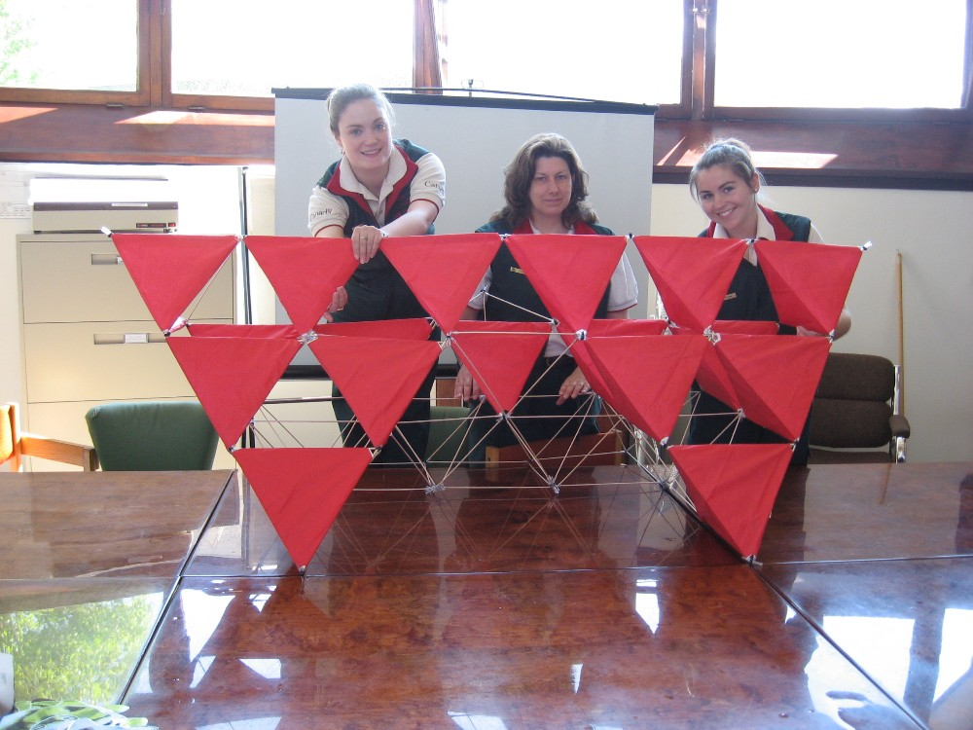

In the photograph L-R is Cygnet 2007 kite creators Jillian Edwards, Jocelyn Bethune and Colleen Ryan. Missing from the photo is their associate kite creator Susan MacDonald who was on a day off at photo time.

Congratulations!!!

Cassie Ann Meagher-Doucet was born on June 18, 2007 in Portage La Prairie,
Manitoba. The proud mother, Kathleen, is working there as a "Research
Agrominist". The proud grandpa, of course, is Tom Meagher, Manager of Asset Management.





Anyone wishing to submit an article to the Hear Ye! Hear Ye!, please forward to Donna at donna.macneil@pc.gc.ca.

