Hear Ye! Hear Ye!

National Historic Sites of Cape Breton Island - Lieux Historiques Nationaux du Cap-Breton
Vol. 8, No.4, April - Avril 2006

News from AGB

The Young Man and Science – An Interview With Dr. Alexander Graham Bell – Reported by C.H. Claudy (From The American Boy for January 1916)

The American Boy wanted an article from Dr. Alexander Graham Bell, scientist, voice specialist, inventor of the telephone, student of aviation. But Dr. Bell was too busy to write such an article.

“If there is any written, you will have to write it!” he said, shaking his head and smiling. “I haven’t time anymore!”

Dr. Bell, however, was willing to talk to the thousands of American boys reached by The American Boy. With that gentle courtesy which has made him famous as a host, he bade me welcome. He took me to that large and beautiful room in his big Washington home, where his well known Wednesday evening gatherings take place; where dwellers in the worlds of science, art and literature gather together in a free assembly to listen to weekly informal talks by one or the other man who has done something.

“I don’t know how to be interviewed,” he said, and his eyes twinkled. “You will have to show me.”

…”While a young man in taking up a scientific career will naturally think of the rewards which it may bring him,” Dr. Bell began, “the true scientific mind seldom gives much thought to the material reward. I am afraid that the true scientist, who follows knowledge for the love of it, is not generally a money maker. But in the field of applied science, and its many practical application, the material rewards are often great…

“But the best rewards of a study of science, whether it be for life work or for its educational value, come in its character building… The scientist searches for exact knowledge. No one can devote any part of his time to a search or study of Truth and not reap the rewards in the strengthening and broadening of his character…The young man who studies scientific things from the love of them, strengthens his moral fibre. One cannot live with Truth and not be truthful.

“But material reward does sometimes come to the scientist…”

This excerpt from the Beinn Bhreagh Recorder XlX, 1916 to be continued in the next ‘Hear Ye’.

And now, on to the month of April 2006 and happenings at AGBNHSC. Lots going on these days.
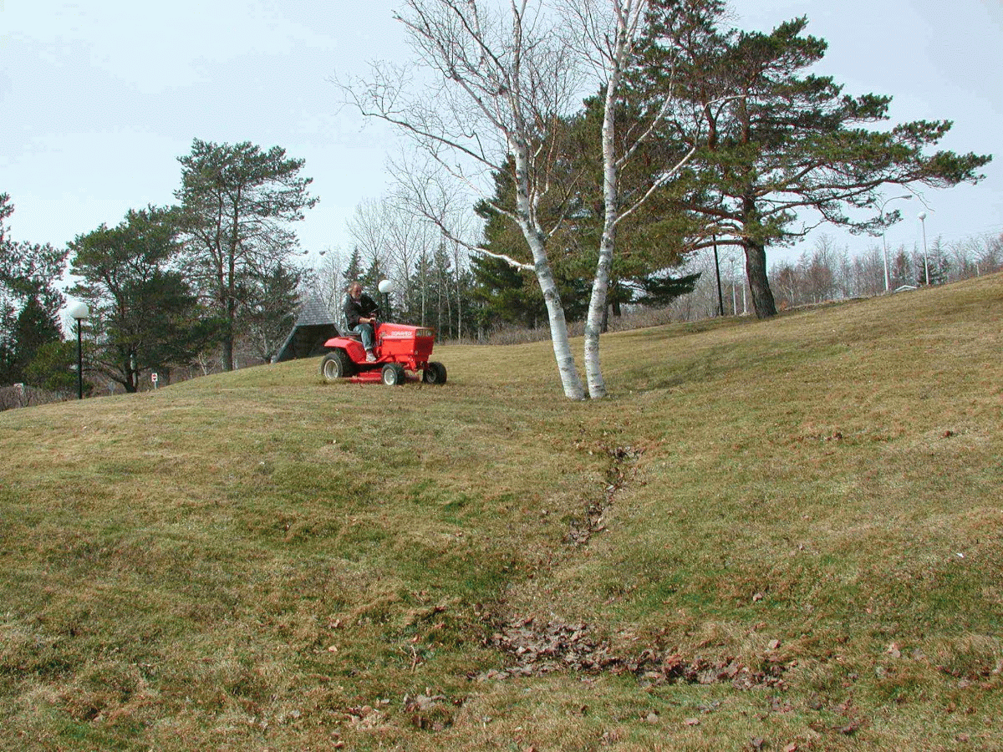
We must begin by letting you know that Gary Pierrard revved up the lawn mower and put it to use on March 31st this year, the earliest ever in our collective memory.

We are working (very preliminary stages) toward the renovation of the rail exhibit panels in the WATER exhibit area which have faded and discoloured to the point that much of their text and images are becoming inaccessible to our visitors.

We are pleased to note that our Welcome Flyer, which has been out of print for about 2 ½ years, is being updated and should be available to our visitors in about 6 weeks. The Alexander Graham Bell Museum Association (AGBMA) has offered to absorb the printing costs and provide a 2-3 year supply.

Historic images are being scanned and forwarded to Formac Publishing in Halifax for the production of a book AGBMA (it is their project) will sell in its Site gift shop. This new publication will be in a ‘Bell Family Albumn’ format focussing on lots of images with minimal text. Text has been created by Judith Tulloch and hopes are that the book will be ready for launching by late summer.

Author Charlotte Gray has been working on a book about Alexander and Mabel Bell and recently we assisted the publisher with locating the source of the image they are using for the cover. They are anticipating a publication time of August 2006.

The Nova Scotia School Board Association will hold its 52nd Annual General Meeting & Conference in Baddeck May 25 –27 at Inverary Inn. AGBNHSC will be setting up an information table with a focus on the fact that Canada’s first Home and School/Parents Association formed in 1895 in Baddeck. We are also providing info and a tetra pin for the delegate welcome kits and will do some field unit cross promotion by providing park and other sites info on the info table. We will also set up the Parks Canada in Schools solo panels.

Rosalynd Ingraham and Lisette Ingraham, our guide service Senior Information Professionals, returned to work April 24th to begin preparations for the visitor season. May 1st is our first day for fee collection which continues until October 31st. Hours of operation for the month of May are 9 a.m. to 5 p.m. daily.

Jess Fraser attended POS training in Halifax this month and while we will use our existing POS this year it is expected the new system will be implemented in 2007.

The Atlantic Outreach Education Team Meeting held in Halifax April 25th & 26th was attended by Greg Joyce, Sharon Morrow and Marie Stradeski. Very briefly, lots of valuable information was imparted especially with regard to outreach opportunities on the web and Parks Canada’s opportunity to continue developing formal ‘ready to go/off the shelf’ lesson plans for teachers to use to in class.

The lesson plan process follows a template and is very detailed in terms of delineating what happens in the lesson and the outcomes the lesson will deliver but can be an extremely effective way to share our stories with young people. Bruce Fisher, NS Social Studies, Curriculum Consultant, gave a talk on the New Atlantic Social Studies Curriculum and how Parks Canada can fit in at different grade levels. There was as well a roundtable with each field unit providing updates and sharing new developments.

FOL -Opening of Site

On Monday, May 1st , the 2006 visitor season will begin. Unlike previous years when site access was limited to three scheduled tours a day, this year we are going to allow visitors access to the upper part of the site (King’s Bastion, Museum and Dela Plagne exhibit).

The purpose is to allow access to visitors who miss the previously scheduled tours. As this is a new approach, we ask all staff to be aware that visitors are on site and that if you see them in the lower part of town to kindly ask them to return to the King’s Bastion area.

Louisbourg Guidebook

The Fortress Louisbourg Association is considering the republication of The Fortress of Louisbourg Guide. That’s a brown book with the silhouette of soldier Julien Comeau and the clock tower of the barracks on the cover. It was written in 1981 by historian Christopher Moore with illustrations by Terry Sunderland.

Anne Marie Lane Jonah has reviewed the text and made changes to bring it up to date. It is amazing the changes that have taken place in building usage since the book was first issued, but the text has held up well over the years.

Anne Marie is also working on an update of the Louisbourg Primer, the basic text for heritage presentation staff.

CBU Archaeology Course &
Public Archaelogy

Rebecca Duggan is getting ready for the Cape Breton University Archaeology Course and the Public Archaeology programme. The CBU course is taught by Jean Pierre Chrestien of the Museum of Civilization in Ottawa and includes 2 weeks of fieldwork in Louisbourg in June. The students will be working on an 18th century lime kiln.

The Public Archaeology programme, sponsored by the Fortress Louisbourg Association, consists of two one-week sessions held in August this year. Fieldwork will take place at the De La Vallière property, carrying on from last year’s studies. Both these programmes help us with important Cultural Resource Management projects, give visitors insight into archaeology and provide good media coverage.

Relay for Life - Canadian Cancer Society

Helen O’Shea is part of a fund raiser for the Canadian Cancer Society called “Relay for Life” which takes place June 9-10 at Victoria Park in Sydney (7 pm to 7 am). Helen is a member of the Louisbourg Royal Bank team called “Friends of Gloria”.


Anyone wishing to learn more about the event can check out the website of http://www.cancer.ca/ccd/internet/standard/0,3182,3172_367994_langld-en,00.html.

If you would like to contribute, you can contact Helen or drop by the Royal Bank and see Debbie Sharpe. Helen is accepting donations up to May 11. An income tax receipt will also be issued with any donations.

Get Active

A memo was received telling us that the Cromarty Tennis Club, Sydney is looking for new adult members. Registration is on May 20/21. It was noted that this club is registered with the Nova Scotia government so that each child membership is eligible for a $150.00 allowable tax deduction.

With summer coming, this would be a great way to get active and stay fit!!! For more details check out their website at:

http://www.cromartytennis.ca/

Condolences

Our sincere condolences to William MacIntosh and his family on the death of his brother, Myles MacIntosh, of Dutch Brook on April 4th.

Also condolences to Philip Burke and Leo Carter on the death of their father-in-law, Willie Campbell, of Bateson, who passed away April 12th.

Anyone wishing to submit an article to the Hear Ye! Hear Ye!, please send to DonnaMacNeil@pc.gc.ca

