96-98 CHARLOTTE STREET BUILDING

DISMANTLE MANUAL

BY

ERIC KRAUSE

KRAUSE HOUSE INFO-RESEARCH SOLUTIONS

DECEMBER 23, 2011
York Street (North) ↓ ↓ North Charlotte Street (East)
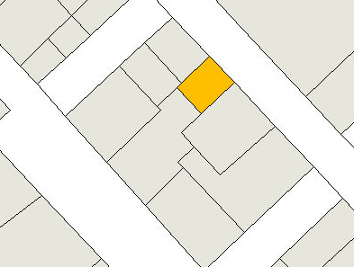
↑ Esplanade (West) ↑ Nepean Street (South)
-----------------------------------
(I) HISTORICAL CONSULTANT

(A) The historical consultant will photograph and record in writing the dismantling of this structure by the contractor.

(B) No work will begin at any location, or proceed unsupervised (unless cleared to do so), without the presence of the historical consultant who will be producing a photographic record of "then and now" as the work progresses.

(C) Work will cease when required to allow for a particular photographic record to be made. Calls for the cessation of work will be kept to the absolute possible minimum.

(D) At any time, the contractor may alert the consultant to a method other than previously agreed to that does not compromise the saving of historical materials, or that increases safety or efficiency, or that is at odds with the proposed work steps detailed later in this report.

(E) The historical consultant will determine what items are of historical significance, thus designating them for storage, and what items are not, thus designating them for elsewhere.

(F) The historic consultant and the contractor will visit the site together at least one day prior to the demolition period, to discuss, step-by-step, the on-site work procedure as well as the proper transportation of historic materials to the storage site. At this time, if practical, the historic consultant will remain behind for several hours to resolve some outstanding items arising from his report of 2010.

(II) OFF-SITE DUMP SITE AND STORAGE AREA

(A) Debris slated for destruction will be taken immediately to the off-site dump site, and not at any time stored on site.

(B) All debris from 96-98 Charlotte Street must be kept separate from other city debris until July, 2011.

(C) Historic material slated for retention will be stored in a dry, covered, location (temporary or permanent) as soon as possible, placed in pre-determined groupings to be identified by the historical consultant. Proper storage procedure is important since time constraints will not allow for the standard-procedure of individual labeling as the materials come off the historic building. Photographs, the written record, and the logical storage system, will thus have to suffice.

(D) This off-site storage area need be acquired prior to the demolition of the building, and visited by the historical consultant, who will identify at least six separated areas where saved materials of historical significance will be sent.

(III) DISMANTLING OF THE STRUCTURE

(A) GENERAL WORKING PRINCIPLES

(a) The identification of original historic materials for storage is based upon a proposed (someday) historical re-establishment of the 18th Century saltbox, which once stood as such at 96-98 Charlotte Street. At that moment, the complex was comprised of an 18th Century East Building, an 18th and early 19th Central West Addition, and an early 19th North Addition. Such was the recommendation that I outlined in my 2010 report on this building. For details, see http://www.krausehouse.ca/krause/96-98CharlotteStreet/Krause96-98CharlotteSt-Updated.doc

(b) In general, the working premise is that the dismantling of this structure will proceed in reverse to the chronological order in which, over time, the six distinct sections of the building were erected.
(B) DISMANTLING IN REVERSE ORDER OF INITIAL CONSTRUCTION

(a) SECTION ONE

(i) Far West Addition (Second): This is the portion farthest to the west raised above the Far West Addition (First).
- Has a ground floor and crawl space.

(b) SECTION TWO

(i) First Floor Addition: This is the raised portion (now fire-damaged) consisting of two portions each with a different depth to the west constructed above the East Building, and West Central and North Additions.
- Has a first floor.

(c) SECTION THREE

(i) North Addition: This is the period portion facing Charlotte Street that one enters through the present door immediately to the north of the East Building.
- Has a ground floor and crawl space.

(d) SECTION FOUR

(i) Far West Addition (First): This is the period portion (partially existing) beneath the Far West Addition (Second) immediately to the west of the Central West Addition.
- Has a ground floor and crawl space.

(e) SECTION FIVE

(i) Central West Addition: This is the period portion immediately to the west of the East Building.
- Has a basement, ground floor, and attic.

(f) SECTION SIX

(i) East Building: This is the period portion facing Charlotte Street that one enters through the present main central entry door.
- Has a basement, ground floor, and attic.
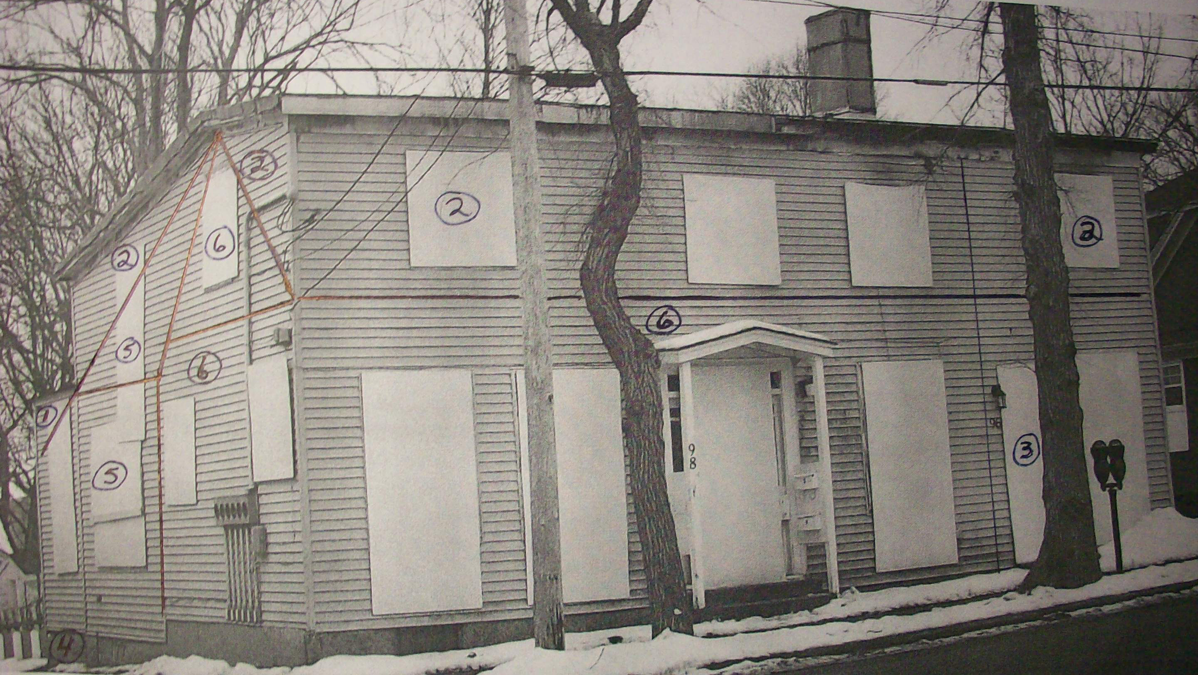

Sections ONE, TWO, THREE, FOUR, FIVE, and SIX
--------------------------------------------
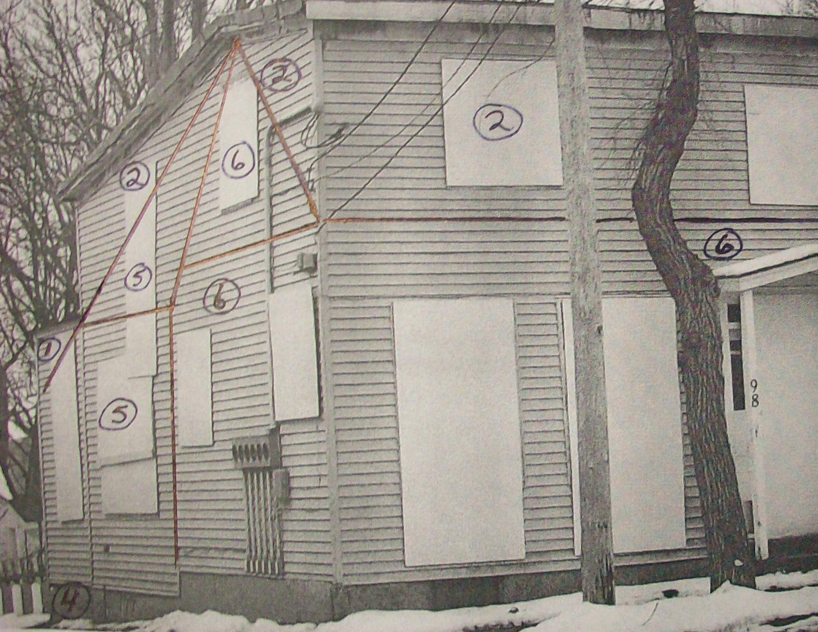
Detail:
Sections ONE, TWO, FOUR, FIVE, and SIX
--------------------------------
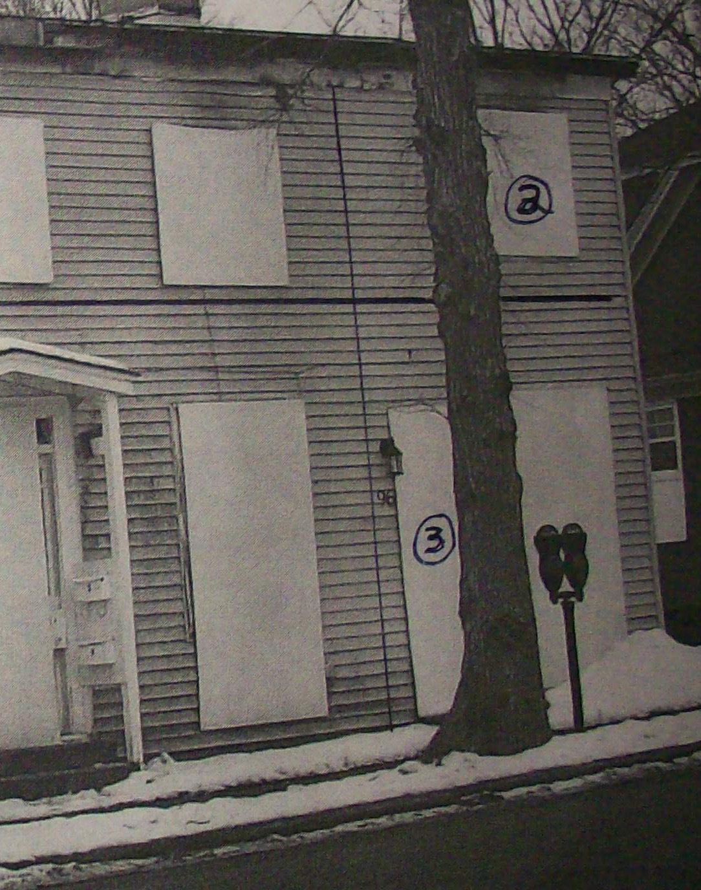
Detail:
Sections TWO and THREE
--------------------------------

(C) THE WORK IN GENERAL: STEP BY STEP

(Step 1) The first step will be the interior gutting of the building, with the removal of materials, either to the correct storage area, or to the dump.

(Step 2) The second step will entail exterior stripping work (walls and roof) and the sending of most of these materials to the dump. The exterior chimney stacks can be dismantled at this time.

(Step 3) The third step will be the removal of exterior sheathings (walls and roof), and the sending of each to the correct storage area.

(Step 4) The fourth step will be the concurrent dismantling of all framing members and the removal of flooring boards, and the sending of each to the correct storage area. At this time the two interior masonry fireplace masses and chimney stacks may be dismantled, or left standing for later demolition.

(Step 5) The fifth step will be a final clean-out of the basements and crawl spaces.

(D) THE WORK IN DETAIL: STEP BY STEP

(a) STEPS: IN GENERAL

(a) Stripping work will generally entail just pulling rather than both prying and pulling of material with a wrecking bar, to minimize damage to the underlying fabric which may be of historical value.

(b) Stripping work will investigate other methods where a wrecking bar will certainly cause damage (for example, the severing of modern nailer strips between period joists, or the cutting of nails between flooring boards and joists, may prove to be practical solutions in some instances).

(c) In all cases, nails and spikes, whether hand-forged, cut, or wire, or whether whole or in pieces, must be set aside for correct storage in properly identified buckets (i.e. identified with a one, two, three, four, five, or six designation). These buckets and other metal products must be secured each evening to prevent thievery as they have known value.

(d) Metal, electrical wiring, etc. of non-historical significance will be set aside and immediately secured against thievery or sent to the scrap-yard.

(e) Generally (but not always if say it is a re-used period wooden piece or member) an item nailed with wire nails will go to the dump.

(b) STEPS: IN DETAIL

STEP I

Interior Work

Gutting the Building

(a) Order of work: It will first begin on the fire-damaged second floor, and, only when finished, followed by the ground floor, and then by the basement areas. During this work, the taking of photos, and the making notes, will be critical, and must proceed logically, floor by floor.

(i) Removed first will be all interior doors with their casings and all windows (with glass panes intact) with their interior and exterior casings (including stools and aprons), with those of historic value (pre-20th century) sent to storage and the others to the dump. This will allow for materials to exit the building without damaging historic fabric in these areas. All exterior openings will be boarded over each evening to secure the work site.

(ii) Removed next, with care, mindful that the underlying material may be of historic value, will be all easily accessible 20th-century non-metal materials, including insulation, ceiling tiles and the like, ceiling tile nailer-strips, plaster-board, PVC/ABS pipe, appliances, furniture, debris on the floors, etc. to be sent immediately to the dump. See above "General to all Steps" for the treatment of metal products.

(iii) Then - in areas designated by the historical consultant - the wall paper and the wall and ceiling lime-based mortar and gypsum plaster work, whether historic or modern, will be stripped off the walls and sent to the dump once some representative samplings have been taken, recorded and sent to storage.

(iv)Then the laths will be stripped off, with the hand-split ones sent to storage. Stripping of historic laths can be a time-consuming process when the goal is to save as many as possible in their entirety. If this work proves too time consuming, the historical consultant will approve a more intrusive method of removing them to speed up the process.

(v) Everything else of historical significance, such as interior wooden wall sheathings (including any attached wall paper), period lath nailer-strips, two intact stair cases, decorative and moulding work, etc. will be removed as carefully as possible, and sent to the storage area. Some fire-damaged materials may be retained if deemed to be of historical research value.

STEP 2

Exterior Stripping Work

(a) Around the entire building, the existing exterior wall siding(s) must be stripped off in a manner causing minimal damage to the original board sheathing to which it is nailed:

(i) The exterior vinyl layer will first be stripped from around the entire building and immediately removed from the property, and sent to the dump.

(ii) The shingle siding beneath will be stripped progressively in a clockwise direction beginning at the north-west corner of the building and once photographed, with samples retained, sent to the dump.

(b) Next or concurrently to wall stripping, all roofing materials must be stripped off in a manner causing minimal damage to the original board sheathing to which it is nailed.

(i) The roofing materials can be sent immediately to the dump, UNLESS wooden shingles are encountered. If such are encountered, an immediate on-site evaluation will be required.

(c) The two exterior masonry chimney stacks can be removed at this time. Their material must be temporarily stored on-site in two separate piles. Once some representative bricks have been removed from the piles and recorded, the bricks, depending on their condition, should either be sent to the dump or be designated for historic re-use and sent to storage.

STEP 3

Exterior Sheathing Removals

(a) The removal of historic wall and roof sheathings must proceed in a careful manner to preserve their integrity. Carefully forcing the boards from within to get a start, or first cutting some of their nails might prove far less damaging than just the use of a wrecking bar alone. All materials are to be sent to storage.

STEP 4

Framing Members, Flooring Boards, and Interior Brick Fireplace Masses

(a) Framing members: These include flooring joists, ground and wall plates, wall posts, rafter members, historic wooden partitions, etc. Where pegged, the pegs are to be removed (and saved where possible) so that the framing assembly can be disassembled.

(i) In particular, the First Floor Addition (TWO) roof contains valuable framing members from an earlier period. As well, the Central West Addition (FIVE) contains earlier dormer remnants.

(b) Flooring boards: The tricky part to removing these boards will be to not split them, or to not break the connecting parts of those that are tongued and grooved, or to separate them where they are double layered.

(c) All materials are to be sent to storage.

(d) At this time (or even earlier or later depending on best procedure) the two interior masonry fireplace masses and chimney stacks can be demolished, with their bricks piled separately on-site. Any iron supports, etc. will be preserved. Once some representative bricks have been removed from the piles and recorded, the bricks, depending on their condition, should either be sent to the dump or be designated for historic re-use and sent to storage.
STEP 5

Final Basement Clean-Out

(a) The rubblestone that comprise the assorted foundations need be examined and a determination made as to what to do with these building rocks. As to bricks, once some representative ones have been removed and recorded, depending on their condition, they should either be sent to the dump or be designated for historic re-use and sent to storage.

(b) Any construction of Portland cement can be sent immediately to the dump.

